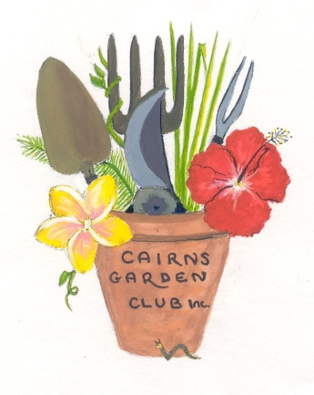
Cairns Garden Club Inc – Information for new members

The Club meets on the third Saturday each month between February and November at various venues, during the wet season in the Bella Vista Community Centre on Loridan Drive, Brinsmead and at other times we visit gardens or other places of interest.
We also enjoy bus trips when possible. Our program is available at the door at meetings, and on the website. Meetings are notified to members by email and Facebook.
The financial year of the Club commences on 1 July each year and subscriptions of $15 are due from that date. The AGM is held in August. From February each year a pro rata fee applies – February, March and April the fee is $10, for new members and in May and June the full fee applies but the membership is current for 14 months. There is also a joining fee for new members of $10.

At each meeting there is a horticultural competition and members are encouraged to enter. A cumulative point score is awarded for the best entries each month and a winner announced at the November meeting each year.

A major event on our program is the Cairns Show in July when our members volunteer to assist the Show Association in the Horticulture Pavilion, acting as stewards and assisting in the running of this section. Members are asked to assist when possible, and we encourage our members to exhibit at the Show, advice about exhibiting is available.

At each meeting members are requested to bring an item for the raffle table. This does not have to be a plant, but please make it something that you would like to take home yourself.

We hope your will enjoy your membership of the Club.

Secretary Carolyn Emslie 0413 192 529 cairnsgardenclub7@gmail.com

-- - - - - - - - - - - - - - - - - - - - - - - - - - - - - - - - - - - - - - - - - - - - - - - - - - - - - - - - - - - - - - - - - - - - - - -
CAIRNS GARDEN CLUB INC – NEW MEMBER2020

Date.................. Receipt No ....…….. .M/ship Number …………
Surname Mr/Mrs/Ms …………………………………………..
Given Name ………………………………………………….
Address .....………………………………………………………….
………………………………………………………………………….
City/Suburb ……………………………Post Code ….............
Telephone ………………………………………………....................
email ………………………………………………............................
Contact person……………………………………………………….
Amount Paid ……………………………………………….
SIGNATURE ………………………………………………..

